**Matlab solvers**

**fmincon**

Most used algorithm for QP are:

* active set
* interior-point
* gradient projection
* alternating direction method of multipliers

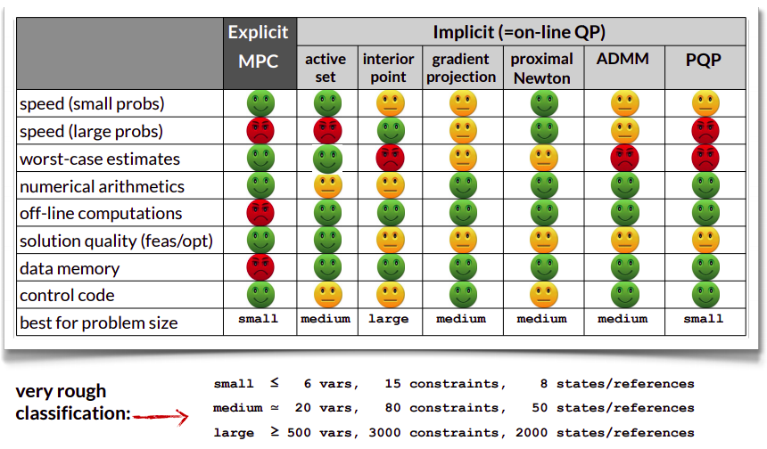

**Robust MPC**

**Tube-Based RMPC**

In presence of bounded uncertainties, all the possible trajectories combinations of an uncertainty system lie in a bounded space of a nominal trajectory, called tube.

Tubes allows to satisfy of the constraints for all the disturbance sequence ensuring that the nominal trajectory satisfies suitably tightened constraints.

**Dynamic system**

Considering the uncertain linear system:

$$x^{+}=Ax+Bu+w$$

where: $x\left(x_{0}, u, w\right)$ solution of the uncertain system

$w∈W$, $w$ state disturbance, $W$ state disturbance constraint set

Considering a nominal linear system:

$${\overline{x}}^{+}=A\overline{x}+B\overline{u}$$

where: is $\overline{x}\left({\overline{x}}_{0}, \overline{u}\right)$ solution of the nominal system

**Preamble**

**Open-loop tube**

Considering an uncertainty linear system and a nominal one, the deviation of the actual state from the nominal state is:

$$e=x-\overline{x}$$

The error evolution derived, for $x_{0}={\overline{x}}_{0}$, is:

$$e^{+}=Ae+w ⟶e_{i}=\sum_{j=0}^{i-1}{A^{j}w\left(j\right)}$$

The uncertainty set is defined accordingly:

$$e_{i}∈S\left(i\right)=\sum_{j=0}^{i-1}{A^{j}W}$$

Finally, the tube is defined as:

$$X\left(x_{0},u\right)={\left[\begin{matrix}X_{0}\left(x_{0}\right) & ⋯ & X_{N}\left(x_{0},u\right)\end{matrix}\right]}^{T}$$

where: $X_{i}\left(x_{0}, u\right)=\left\{{\overline{x}}_{i}\right\}⊕S_{i}$

$\left\{{\overline{x}}_{i}\right\}$ nominal state defining the centre of the tube

It can be proof that with an open loop control, the tube $X_{i}$ increases in dimension as i increases, since the uncertainty set increases and then the trajectory can diverge.

The solution to this is using a feedback control to control the size of $S_{i}$ and then make the actual trajectory converge to the nominal one.

**Closed-loop tube**

The feedback control law proposed is:

$$u=\overline{u}+K\left(x-\overline{x}\right)=\overline{u}+Ke$$

The state x satisfies the difference equation:

$$x^{+}=Ax+B\overline{u}+BKe+w$$

The deviation and the error evolution:

$$e=x-\overline{x}$$

The error evolution derived, for $x_{0}={\overline{x}}_{0}$, is:

$$e^{+}=\left(A+BK\right)e+w=A_{K}e+w ⟶e_{i}=\sum_{j=0}^{i-1}{A_{K}^{j}w\left(j\right)}$$

The uncertainty set is defined accordingly:

$$e_{i}∈S_{K}\left(i\right)=\sum_{j=0}^{i-1}{A_{K}^{j}W}$$

The tube generated is:

$$X\left(x_{0},u\right)={\left[\begin{matrix}X_{0}\left(x_{0}\right) & ⋯ & X_{N}\left(x_{0},u\right)\end{matrix}\right]}^{T}$$

where: $X_{i}\left({\overline{x}}_{0}, \overline{u}\right)=\left\{{\overline{x}}_{i}\right\}⊕S_{i}$

$\left\{{\overline{x}}_{i}\right\}$ nominal state defining the centre of the tube

**Existence of the minimal robust positive invariant set**

The uncertainty set at a certain instant $S_{K}\left(i\right)$ can be replaced by the:

* Minimal robust positive invariant set $S_{K}\left(∞\right)$ to obtain a more conservative outer-bounding tube
* $S_{K}\left(H_{p}\right)$ to obtain a less conservative outer-bounding tube

**Origin condition relaxation**

Furthermore since $S_{K}\left(∞\right)$ exists whenever $A_{K}$ is stable, can be proven that it is possible to relax the condition $x_{0}={\overline{x}}_{0}$.

**Constraints**

Defining the uncertain and nominal system constraint set as:

$$\left\{\begin{aligned}x∈X_{c} \\ u∈U_{c}\end{aligned}\right.⟹\left(x,u\right)∈Z$$

$$\left\{\begin{aligned}\overline{x}∈{\overline{X}}_{c}=X_{c}⊖S_{K}\left(∞\right) \\ \overline{u}∈{\overline{U}}_{c}=U_{c}⊖KS_{K}\left(∞\right)\end{aligned}\right.⟹\left(\overline{x}, \overline{u}\right)∈\overline{Z}=Z⊖\left(S_{K}\left(∞\right)×KS_{K}\left(∞\right)\right)$$

The tube-based MPC is made up by:

1. Nominal state-control trajectory that satisfies the tightened constraint:
$$\overline{x}\left(k\right), \overline{u}\left(k\right)$$

2. Feedback controller that track the nominal trajectory

$$u=\overline{u}+K\left(x-\overline{x}\right)=\overline{u}+Ke$$

where: $e=x-\overline{x}$ deviation of the actual state

The nominal state-control trajectory can be:

* generated once at initial time
* generated sequentially using standard MPC for deterministic system

**Nominal trajectory**

For the nominal system

$${\overline{x}}^{+}=A\overline{x}+B\overline{u}$$

it is solved the standard optimal control problem:

$$\begin{matrix}{\overline{V}}^{*}=\min_{\overline{x},\overline{u}}{\overline{V}\left(\overline{x},\overline{u}|k\right)} \\ s.t. \left|\begin{aligned}dynamic model \\ constraints\end{aligned}\right.\end{matrix}$$

$$\overline{V}\left(\overline{x},\overline{u}|k\right)=\sum_{i=k}^{k+H_{p}-1}{l\left(\overline{x}\left(i|k\right),\overline{u}\left(i|k\right)\right)}+V_{f}\left(\overline{x}\left(k+H_{p}|k\right)\right)$$

which solution gives the control law:

$${\overline{u}}^{*}=\overline{κ}\left(\overline{x}\right)$$

Then the controlled nominal system is described by:

$${\overline{x}}^{+}=A\overline{x}+B\overline{κ}\left(\overline{x}\right)$$

**Feedback controller**

The feedback controller generates the (proposed) control law:

$$u=\overline{κ}\left(\overline{x}\right)+K\left(x-\overline{x}\right)$$

Then the controlled system is described by:

$$x^{+}=Ax+B\overline{κ}\left(\overline{x}\right)+K\left(x-\overline{x}\right)+w=Ax+B\overline{κ}\left(\overline{x}\right)+Ke+w$$

where: $e=x-\overline{x}$ deviation of the actual state, satisfies:

$$e^{+}=\left(A+BK\right)e+w=A_{K}e+w$$

which is the error evolution.

**System state and dynamic model**

Considering two systems:

1. system with state $\left(x,\overline{x}\right)$ satisfies:
$$x^{+}=Ax+B\overline{κ}\left(\overline{x}\right)+Ke+w$$

$${\overline{x}}^{+}=A\overline{x}+B\overline{κ}\left(\overline{x}\right)$$

2. system with state $\left(e,\overline{x}\right)$ satisfies:

$$e^{+}=A_{K}e+w$$

$${\overline{x}}^{+}=A\overline{x}+B\overline{κ}\left(\overline{x}\right)$$

Since they are proportional with through an invertible matrix T, they are equivalent.

**Uncertainty set S**

Setting the initial condition: $x\left(0\right)=\overline{x}\left(0\right)→e\left(0\right)=0$

**Constraints**

**Tightened constraint**

$$\left(\overline{x}, \overline{u}\right)∈\overline{Z}=Z⊖\left(S_{K}\left(∞\right)×KS_{K}\left(∞\right)\right)$$

Suppose $Z$ is a polytope and described by a set of scalar inequalities:

$$c^{'}z≤d$$

It can be proof that constraints of this form can be replaced by constraint of the form:

$$c^{'}\overline{z}≤d-{\left(1-α\right)}^{-1}θ_{N}$$

ensuring that the satisfaction of this the tightened constraint by the nominal system ensures that the uncertain system satisfies the original constraint.

**Time-varying Tightened constraint**

The constant tightened constraint set $\overline{Z}$ is conservative, reducing unnecessarily the feasible set ${\overline{X}}_{N}$. This conservativeness can be decreased using time-varying constraint set:

$$\overline{Z}\left(k\right)=Z⊖\left(S_{K}\left(k\right)×KS_{K}\left(k\right)\right)$$

**Final Notes**

* Computation of tightened constraints may be expensive